Animation tick sheet


Use the tick sheet to help you to create an effective flipbook animation.

- Start on the bottom sheet

- Draw your stick person (make it simple)

- Turn over the next page

- Make a change to the part of the drawing that you want to move

- Copy the rest of the drawing


- Repeat until all pages have a drawing on
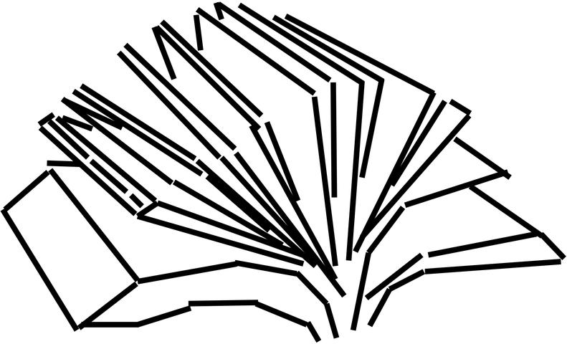
- Flip through the pages to see your animation

Resources are updated regularly — the latest version is available at: ncce.io/tcc.

This resource is licensed under the Open Government Licence, version 3. For more information on this licence, see ncce.io/ogl.

